**TRAFFIC MANAGEMENT SYSTEM**

**ABOUT:**

A Traffic Management System (TMS) is a comprehensive infrastructure and technology solution

designed to efficiently manage and control traffic flow on roadways, highways, and in urban areas. The primary goal of a TMS is to enhance road safety, reduce congestion, optimize traffic flow, and improve transportation efficiency.

**GOAL:**

The primary goal of a Traffic Management System (TMS) project is to enhance the management and

control of traffic on roadways and in urban areas. This is achieved through optimizing traffic flow, improving road safety, reducing congestion, and minimizing environmental impact. TMS provides real-time information to commuters, efficiently manages traffic incidents, and integrates with public transportation systems. Overall, TMS aims to create a safer, more efficient, and environmentally friendly transportation network.

**HOW IT IS USEFUL:**

A Traffic Management System (TMS) is highly beneficial as it enhances traffic flow, improves road safety, reduces congestion, and minimizes environmental impact. It offers real-time information to commuters, efficiently manages incidents, integrates with public transportation, and supports data-driven decision-making. TMS promotes sustainability and results in a safer, more efficient transportation network, benefiting both commuters and the environment.

**SOFTWARE REQUIREMENTS:**

The essential software components used in building a Traffic Management System (TMS) include:

* Traffic data collection and analysis software.
* Traffic signal control software.
* Incident management software.
* Data sharing and communication software.
* Predictive modelling software.
* Public transportation integration software.
* Environmental impact management software.
* Remote monitoring and control software.

**HARDWARE REQUIREMENTS:**

For a project integrating historical traffic data and machine learning for congestion prediction using IoT, the hardware requirements include:

* Traffic sensors
* IoT gateways
* Data processing servers
* IoT network infrastructure
* Machine learning hardware
* Data storage
* Power backup systems
* Traffic cameras

**DESIGN FLOW:**

The project flow for integrating historical traffic data and machine learning for congestion prediction

using IoT can be distilled into key steps:

* Planning and Hardware Setup: Define project goals and select hardware components.
* Data Collection: Gather real-time data from sensors and IoT gateways.
* Data Processing and Storage: Process and store data for analysis.
* Machine Learning Models: Develop predictive models based on historical data.
* Real-time Analysis: Continuously analyze current traffic data.
* Congestion Prediction: Use machine learning to forecast congestion.
* Data Visualization and Reporting: Present insights through user interfaces and reports.
* Deployment and Maintenance: Launch the system and maintain its performance.
* Security and Compliance: Ensure data and system security, and adhere to regulations.
* Testing, Training, and Scalability: Rigorously test the system, train users, and plan for future growth.

**COMPONENTS:**

The following are the selected hardware components for the project:



**Traffic Sensors:** These are various sensors such as loop detectors, radar sensors, and cameras used to collect real-time traffic data.

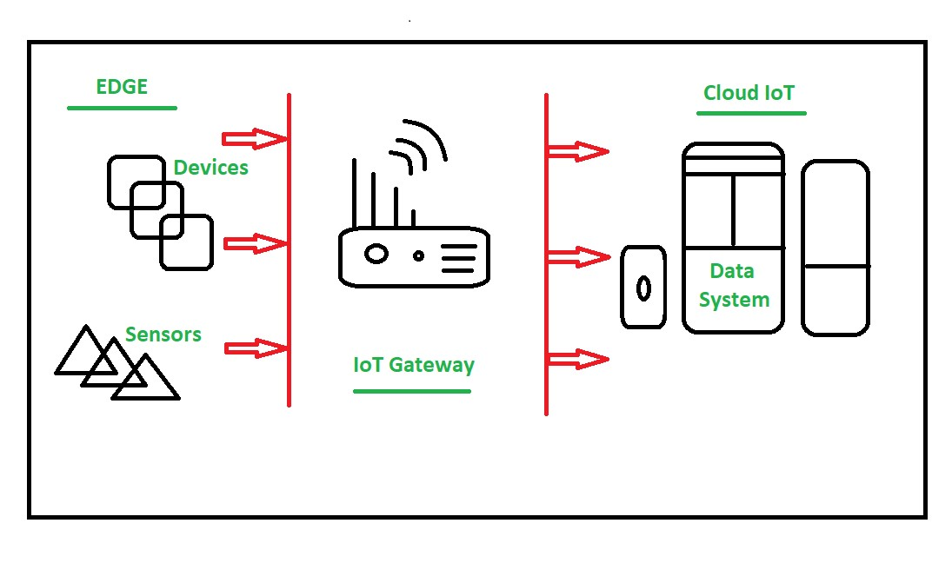

**IoT Gateways:** Devices that collect data from traffic sensors and transmit it to a central processing system.

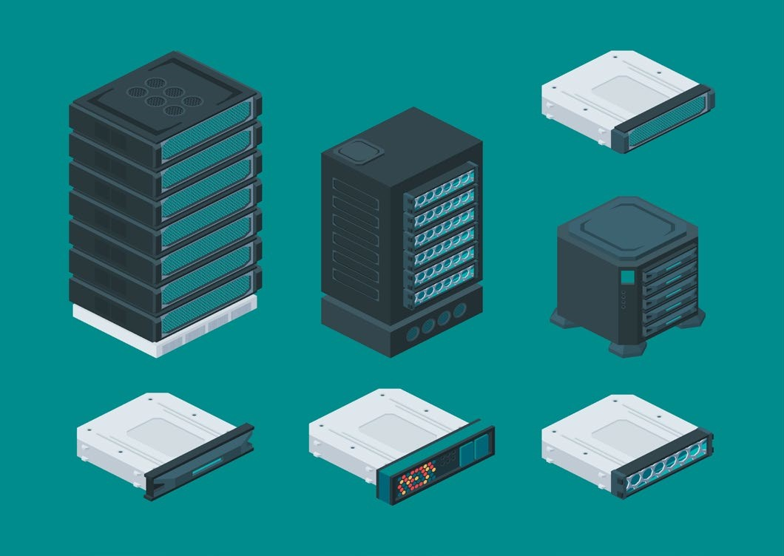

**Data Processing Servers:** High-performance servers for data storage, pre-processing, and running machine learning algorithms.

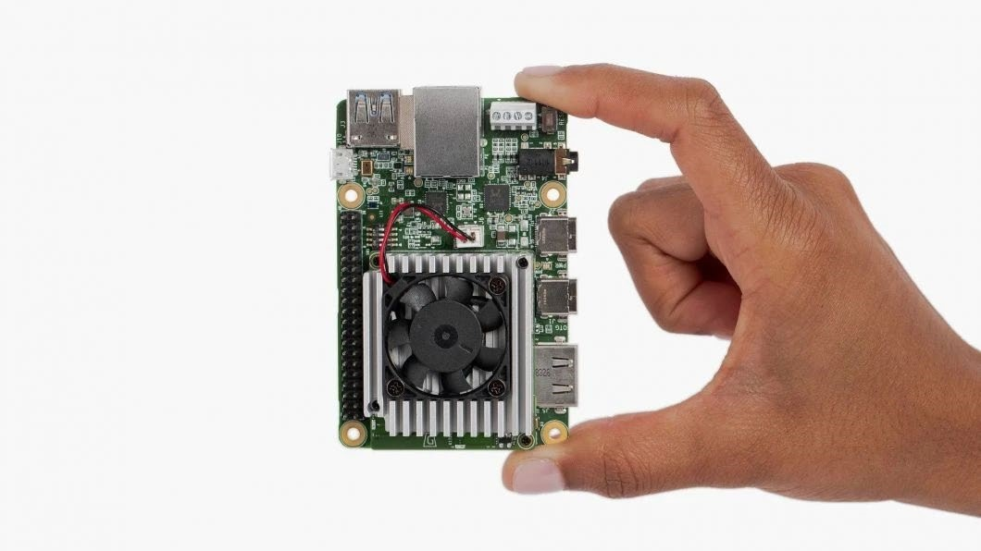

**Machine Learning Hardware:** Hardware accelerators like GPUs or TPUs used for machine learning model training.



**Traffic Cameras**: High-resolution cameras for collecting visual data.

**PROPOSED SYSTEM ARCHITECTURE:**

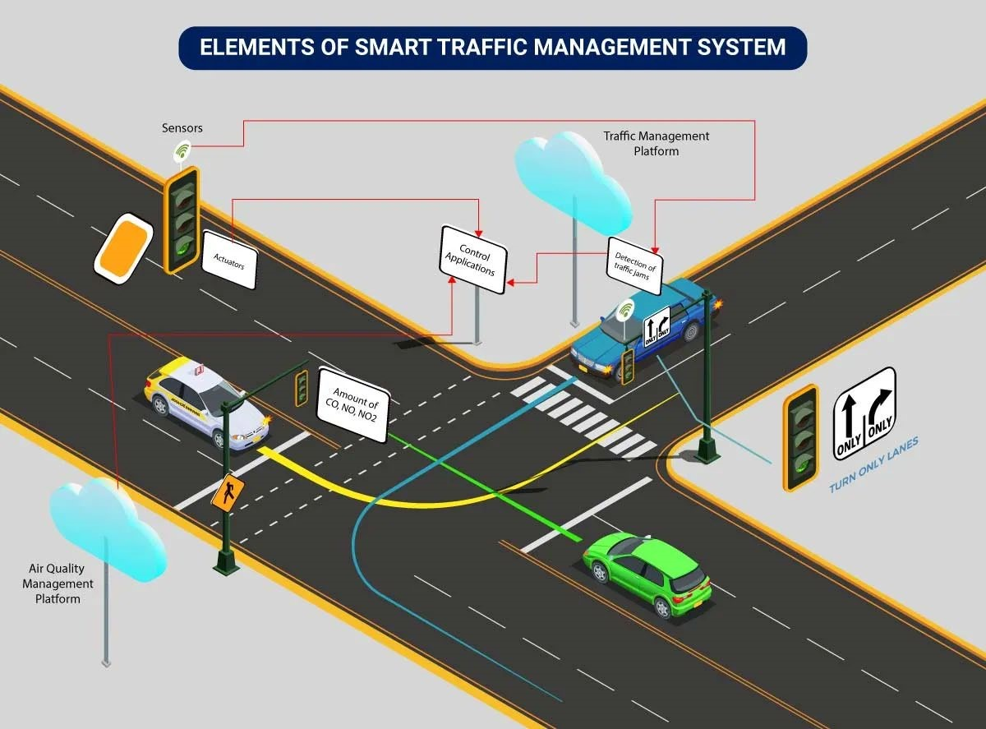

The system architecture of a Traffic Management System (TMS) outlines how various components, such as traffic sensors, data processing servers, machine learning models, and communication infrastructure, work together to monitor, analyze, and predict traffic conditions. It details how data flows from sensors to servers for real-time analysis, congestion prediction, and user interface display. TMS architecture focuses on data reliability, security, and scalability to ensure efficient traffic management, providing a structured framework for traffic data collection, processing, and decision-making.

**PYTHON CODE:**

**python**

**import pandas as pd**

**from sklearn.ensemble import RandomForestRegressor**

**from sklearn.model_selection import train_test_split**

**from sklearn.metrics import mean_squared_error**

**import matplotlib.pyplot as plt**

**data = pd.read_csv('historical_traffic_data.csv')**

**X = data.drop(columns=['congestion_level'])**

**y = data['congestion_level']**

**X_train, X_test, y_train, y_test = train_test_split(X, y, test_size=0.2, random_state=42)**

**model = RandomForestRegressor(n_estimators=100, random_state=42)**

**model.fit(X_train, y_train)**

**y_pred = model.predict(X_test)**

**~mse = mean_squared_error(y_test, y_pred)**

**print(f"Mean Squared Error: {mse}")**

**plt.scatter(y_test, y_pred)**

**plt.xlabel("Actual Congestion")**

**plt.ylabel("Predicted Congestion")**

**plt.title("Actual vs. Predicted Congestion Levels")**

**plt.show()**

**CONCLUSION:**

**Project Overview:** The Traffic Management System (TMS) is a comprehensive project aimed at efficiently managing and controlling traffic flow on roadways and in urban areas. It integrates historical traffic data, realtime data collection through IoT, and machine learning algorithms to predict congestion patterns and enhance overall traffic management.

**Project Output:** The primary output of the project is an intelligent traffic management system capable of predicting traffic congestion in real-time. It provides insights into traffic conditions, allows for proactive decision-making by authorities, and communicates this information to the public.

**Result and Functionality:** The result of the project is an advanced TMS that continuously collects, processes, and analyzes traffic data. Machine learning models predict congestion patterns and provide timely alerts. The system's effectiveness is based on historical data and real-time inputs, enabling authorities to take proactive measures to alleviate congestion and improve overall traffic flow.

**Public Benefits:** The TMS project greatly benefits the public by reducing congestion, minimizing travel time, enhancing road safety, and promoting eco-friendly transportation practices. Real-time traffic information is disseminated through various channels, allowing commuters to make informed decisions about their routes. This not only reduces stress and frustration but also contributes to environmental sustainability through reduced fuel consumption and emissions. Ultimately, the Traffic Management System serves the public by making their daily commutes smoother and more efficient.